1-Bedroom Properties

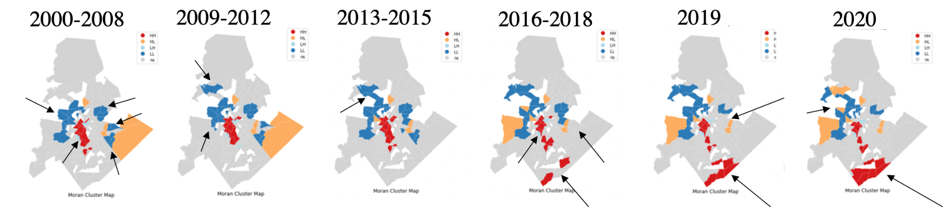

2-Bedroom Properties

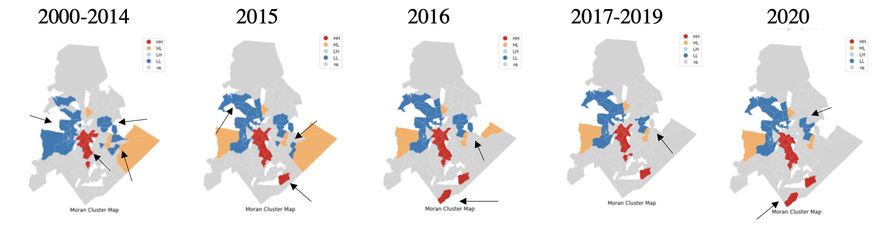

3-Bedroom Properties

